Chapter 1

INTRODUCTION

This Chapter gives overview of the project, the problem statement, the proposed solution, the objective of project and about the organization of report

- Overview

A typical home automation system allows one to control house-hold appliances from a centra
-lized control unit. These appliances include lights, fans, air conditioners, television sets, security cameras, electronic doors, computer systems, audio/visual equipment, etc. These appliances usually have to be specially designed to be compatible with each other and with the control unit for most commercially available home automation systems.

Although home automation today is not a new thing but most advanced home automation systems in existence today require a big and expensive change of infrastructure. This means that it often is not feasible to install a home automation system in an existing building.

The Project will be implemented using the Arduino Uno device with various programmable sensors to test the temperature, light sensitivity, number of persons in the room and the sensed data will be continuously monitored by the device and functionalities will be exploited accordingly.

- Problem Statement

Traditional way of automating the home is being done by using Internet. All these process are tedious to follow and many times the cost involved is too high and insecure resulting in financial loss and exposure to hacking.

- Existing System

Most commercially available home automation systems are all-in-one solutions which require that all controllable appliances are from the same company, or must be approved as compatible with said company’s system. Moreover, these systems normally come with a proprietary, dedicated device which acts as the control center. To control the system from multiple locations, additional control devices must be purchased.

These complex systems usually need to be integrated when the building is constructed and must be planned in advance. They are also difficult to upgrade or replace once installed. The overall investment adds up considerably and is financially infeasible in most cases. These drawbacks hinder the popularity of such systems.

- Proposed Solution

The objective of the proposed system is to offer a low-cost solution for a home automation system that overcomes the above drawbacks. The system provides basic control of appliances at a fraction of the cost of commercially available systems.

An Arduino system along with the programmable sensors like temperature sensor, Light detection sensor, real time clock, laser module to continuously sense the data and the sensed data will be extracted by the program and sent to the Arduino board, depending upon the sensed values , the necessary actions can be performed.

- Objective of the project

The objective of this project is to implement a low cost, reliable and scalable home automation system that can be used to remotely switch on or off any household appliance, using a microcontroller to achieve hardware simplicity, low cost voice recognition module for giving the command from any place to toggle the switch state.

- Organization of Report

The rest of the report is organized as follows:

Chapter 2 deals with literature survey and the technologies used which is part of the project.

Chapter 3 briefs the software requirements specification, functionality, working environment and output format.

Chapter 4 gives the complete design i.e. architecture, data flow diagrams, use case diagram, module diagram and sequence diagram.

Chapter 5 deals with the implementation of the project.

Chapter 6 deals with software testing.

Chapter 7 gives the results and snapshots.

Next is the Conclusion and future work of the project. It briefly tells what the project is doing and what has been accomplished. Future work is also specified in this section.

Apart from the above, the References used are listed and the appendix provides snapshots of various interfaces used in the project.

//literature Survey

Chapter 2

LITERATURE SURVEY

The purpose of this literature survey is to provide background information on the issues to be considered in this thesis and to emphasize the relevance of the present study. This Chapter gives the survey of associated technologies and summary of related work done in the past.

A brief study and survey has been carried out so far to understand various issues related to the project. Since our project is related to home automation, a brief study on home automation is carried out successfully.

A brief study on the working of Arduino IDE is carried out and successfully installed the all prerequisites (ARDUINO) required by the tool.

A study on all versions of voice recognition module is being done.

2.1 HISTORY OF HOME AUTOMATION:
Home automation has been around since the world war 1 (1914), in fact, the television remote (a simple home automation system) was patented in 1893 (Wikipedia, 2009). Since then different home automation systems have evolved with a sharp rise after the second World War. It's growth has been through various informal research and designs by technology enthusiasts who want a better way of getting things done at home without much effort on their part. The systems evolved from one that can automatically do routine chores like switch on and off security lights, to more sophisticated ones that can adjust lighting, put the television channel to favorite station and control doors.

2.2 HOME AUTOMATION SYSTEMS:
Home automation systems may designate electronic systems in homes and residential buildings that make possible the automation of household appliances. The new stream of home automation systems has developed into a vast one and the current market is flooded with a flurry of home automation systems and device manufacturers.
Some of the home automation systems are :-
- Individual Control Systems 7 These types were the first to hit the market in the early years, here each device like the heater or the air conditioner will have an independent control dedicated to it.
- Distributed Control Systems The main feature of these type of systems is emergency shut-down. With this system you can preset or change the control parameters of several similar devices, for example, the thermostat of several air conditioners and their ON/OFF timings.
- Central Control Systems These are computerized systems programmed to handle all functions of multiple utilities like air conditioning system, home entertainments, doors, windows, refrigerators and cooking systems, all at the same time regardless of whether you are at home or away. You can connect to the control system through telephone or internet from anywhere in the world.

- Power line carrier Systems The least expensive type of home automation system operates over the home's existing wiring, or powerline carrier. These can range from X10- based lamp timers , to more sophisticated systems that require installation by a trained professional.

- Wireless systems Also available are wireless home automation systems that utilize radiofrequency technology. They are often used to operate lights, sometimes in conjunction with a hardwired lighting control system.

- Hardwired systems Wired, or “hardwired” home control systems are the most reliable and expensive. These systems can operate over high-grade communications cable such as Category 5 or 5e, or their own proprietary “bus” cable. That is why it is best to plan for them when a house is being constructed. Hardwired systems can perform more tasks at a time and do them quickly and reliably, making them ideal for larger homes. They can also integrate more systems in the home, effectively tying together indoor and outdoor lighting, audio and video equipment, security system, even the heating and cooling system into one control package that will be easy and intuitive to operate.

- Internet Protocol control system Internet Protocol (IP) control automation system uses the internet, gives each device under its control an Internet Protocol address, and creates a local area network (LAN) in the home. Hence, the home can be interacted with over the internet with possibility of live video streaming and real-time control

2.3 Arduino

Arduino is an open-source electronics platform based on easy-to-use hardware and software. Arduino boards are able to read inputs - light on a sensor, a finger on a button, or a Twitter message - and turn it into an output - activating a motor, turning on an LED, publishing something online. You can tell your board what to do by sending a set of instructions to the microcontroller on the board. To do so you use the Arduino programming language (based on Wiring), and the Arduino Software (IDE), based on Processing.

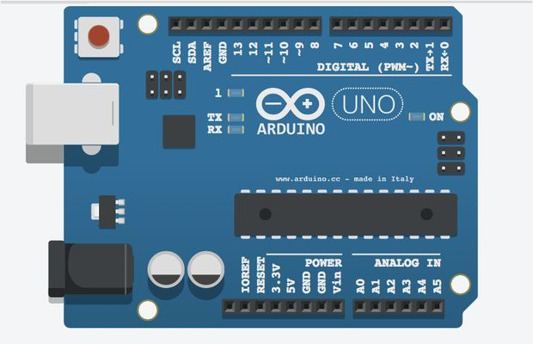
Figure 2.1 : Arduino

2.3.1 Hardware
The board can operate on an external supply from 6 to 20 volts. If supplied with less than 7V, however, the 5V pin may supply less than five volts and the board may become unstable. If using more than 12V, the voltage regulator may overheat and damage the board. The recommended range is 7 to 12 volts.

2.3.2 Microcontroller
A microcontroller (or MCU for microcontroller unit) is a small computer on a single integrated circuit. In modern terminology, it is a System on a chip or SoC. A microcontroller contains one or more CPUs (processor cores) along with memory and programmable input/output peripherals. Program memory in the form of Ferroelectric RAM, NOR flash or OTP ROM is also often included on chip, as well as a small amount of RAM. Microcontrollers are designed for embedded applications, in contrast to the microprocessors used in personal computers or other general purpose applications consisting of various discrete chips.
Microcontrollers are used in automatically controlled products and devices, such as automobile engine control systems, implantable medical devices, remote controls, office machines, appliances, power tools, toys and other embedded systems. By reducing the size and cost compared to a design that uses a separate microprocessor, memory, and input/output devices, microcontrollers make it economical to digitally control even more devices and processes. Mixed signal microcontrollers are common, integrating analog components needed to control non-digital electronic systems.
Some microcontrollers may use four-bit words and operate at frequencies as low as 4 kHz, for low power consumption (single-digit milliwatts or microwatts). They will generally have the ability to retain functionality while waiting for an event such as a button press or other interrupt; power consumption while sleeping (CPU clock and most peripherals off) may be just nanowatts, making many of them well suited for long lasting battery applications. Other microcontrollers may serve performance-critical roles, where they may need to act more like a digital signal processor (DSP), with higher clock speeds and power consumption.

2.3.3 Processor

The ATmega328 has 32 KB (with 0.5 KB occupied by the bootloader). It also has 2 KB of SRAM and 1 KB of EEPROM

2.3.4 Memory

The ATmega328 has 32 KB (with 0.5 KB occupied by the bootloader). It also has 2 KB of SRAM and 1 KB of EEPROM

2.4 Sensors

2.4.1 Temperature Sensor( KY-013)
- Temperature sensors are measurement devices that determine temperature by sensing a corresponding physical characteristic, such as electrical resistance, electromagnetic field (EMF) or thermal radiation
- The way a temperature sensor works depends upon the physical property that is measured.

- Specifications of temperature sensor are Temperature measurement, Accuracy, Stability, Probe type and Termination style.

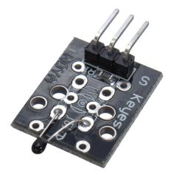
Figure 2.2 : Temprature Sensor

Building the circuit

- Connect pin 3 of temperature gauge to A0 of Arduino uno.

- Connect pin 2 of temperature gauge to +5v (pin 4).

- Connect pin 1 of temperature gauge to GND (pin 5)

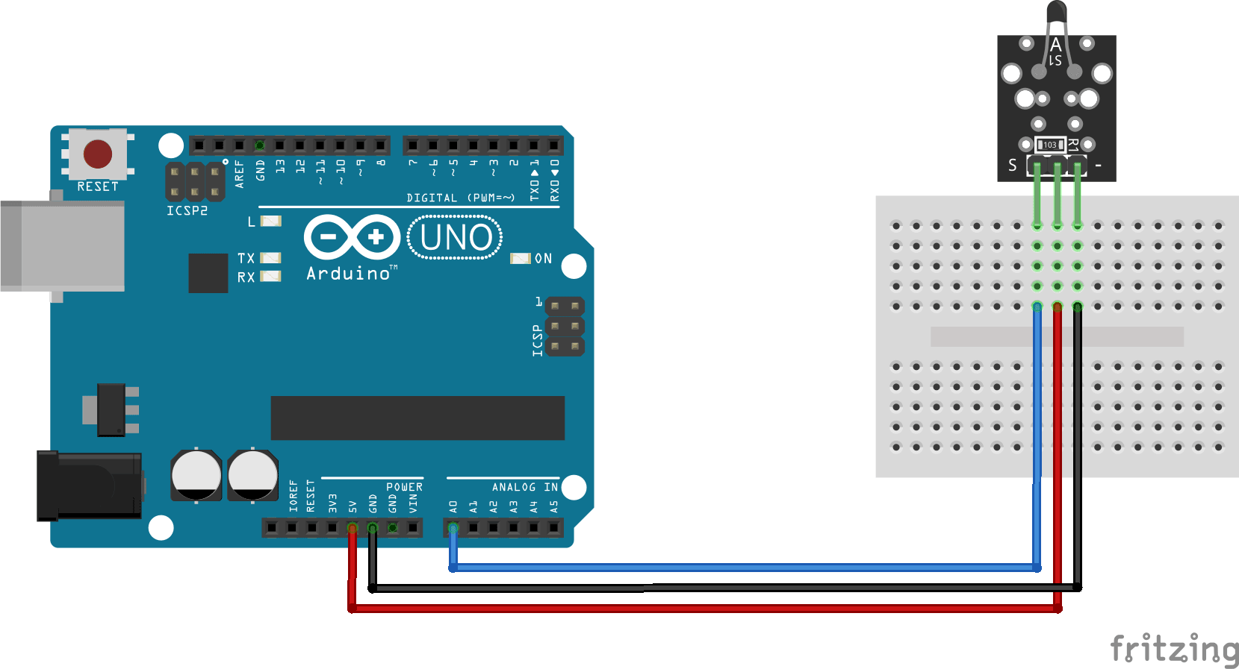
Figure 2.3: circuit diagram temperature sensor

2.4.2 Light Sensing Module – LDR

- Detects if there is light or dark around, adjustable digital output trigger level, Analog+Digital output
- Photosensitive resistor module most sensitive to environmental light intensity is generally used to detect the ambient brightness and light intensity.
- Module light conditions or light intensity reach the set threshold, DO port output high, when the external ambient light intensity exceeds a set threshold, the module D0 output low;
- Digital output D0 directly connected to the MCU, and detect high or low TTL, thereby detecting ambient light intensity changes;
- Digital output module DO can directly drive the relay module, which can be composed of a photoelectric switch;
- Analog output module AO and AD modules can be connected through the AD converter, you can get a more accurate light intensity value

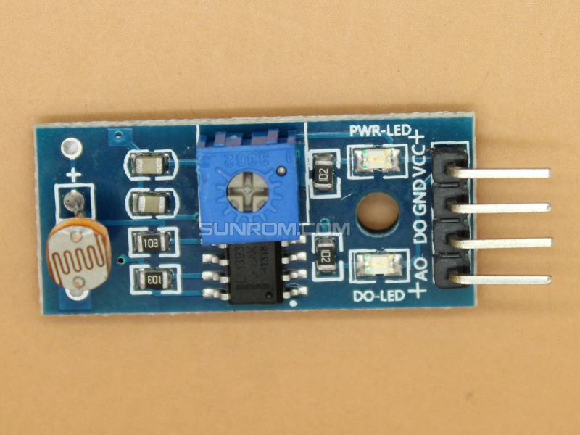

Figure 2.4: Light sensing module- LDR

Building the circuit

- Connect pin 4(A0) of Light sensing module to A1 of Arduino uno.

- Connect pin 2 of Light sensing module to GND (pin 5) of Arduino uno.

- Connect pin 1 of Light sensing module to +5v (pin 4) of Arduino uno.

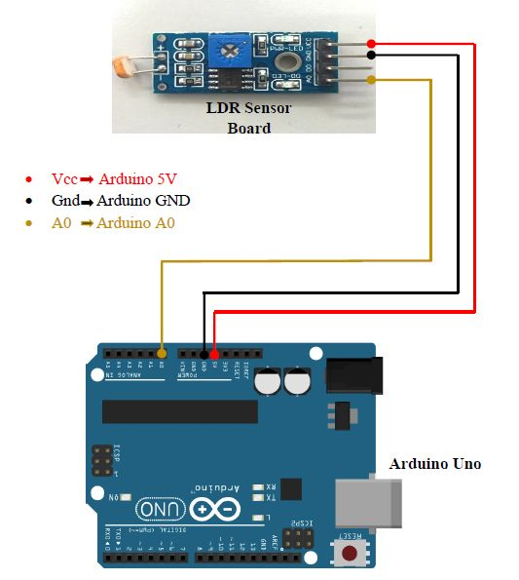

Figure 2.3: circuit diagram light sensing module sensor

2.4.3 Real time clock module

- The DS3231 is a low-cost, extremely accurate I2C real-time clock (RTC) with an integrated temperaturecompensated crystal oscillator (TCXO) and crystal.
- The device incorporates a battery input, and maintains accurate timekeeping when main power to the device is interrupted.
- The integration of the crystal resonator enhances the long-term accuracy of the device as well as reduces the piece-part count in a manufacturing line.
- The DS3231 is available in commercial and industrial temperature ranges, and is offered in a 16-pin, 300-mil SO package.
- The RTC maintains seconds, minutes, hours, day, date, month, and year information. The date at the end of the month is automatically adjusted for months with fewer than 31 days, including corrections for leap year.
- The clock operates in either the 24-hour or 12-hour format with an AM/PM indicator.
- Two programmable time-of-day alarms and a programmable square-wave output are provided. Address and data are transferred serially through an I2C bidirectional bus.

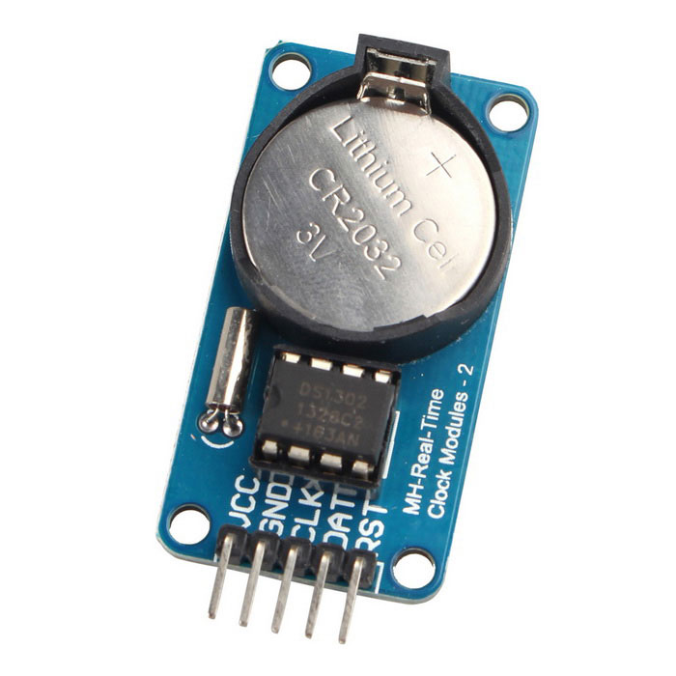
Figure 2.4: RTC module

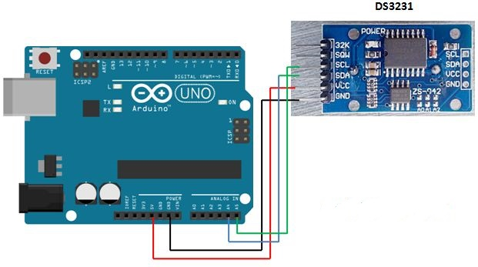
Figure 2.5: circuit diagram RTC

Building the circuit

  - Connect pin SDA of RTC to A4 of Arduino uno.
  - Connect pin SCL of RTC to A5 of Arduino uno.
  - Connect pin VCC of RTC to +5V (pin 4) of Arduino uno.
  - Connect pin GND of RTC to GND (pin 5) of Arduino uno.

2.4.4 laser diode

- A laser is a device that emits light through a process of optical amplification based on the stimulated emission of electromagnetic radiation.
- The term "laser" originated as an acronym for "light amplification by stimulated emission of radiation"
- The first laser was built in 1960 by Theodore H. Maiman at Hughes Research Laboratories, based on theoretical work by Charles Hard Townes and Arthur Leonard Schawlow.
- A laser differs from other sources of light in that it emits light coherently. Spatial coherence allows a laser to be focused to a tight spot, enabling applications such as laser cutting and lithography.
- Spatial coherence also allows a laser beam to stay narrow over great distances (collimation), enabling applications such as laser pointers.
- Lasers can also have high temporal coherence, which allows them to emit light with a very narrow spectrum, i.e., they can emit a single color of light.
- A laser diode, or LD also known as injection laser diode or ILD, is an electrically pumped semiconductor laser in which the active laser medium.
- It is formed by a p-n junction of a semiconductor diode similar to that found in a light-emitting diode.

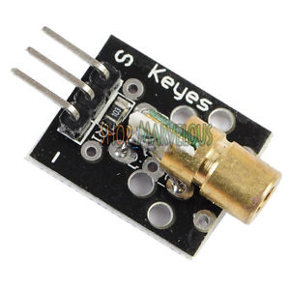
Figure 2.6 : Laser Diode

2.4.5 Voice Recognition Module

- ELECHOUSE Voice Recognition Module is a compact and easy-control speaking recognition board.
- This product is a speaker-dependent voice recognition module. It supports up to 80 voice commands in all.
- Max 7 voice commands could work at the same time. Any sound could be trained as command.
- Users need to train the module first before let it recognizing any voice command.
- This board has 2 controlling ways: Serial Port (full function), General Input Pins
- General Output Pins on the board could generate several kinds of waves while corresponding voice command was recognized.

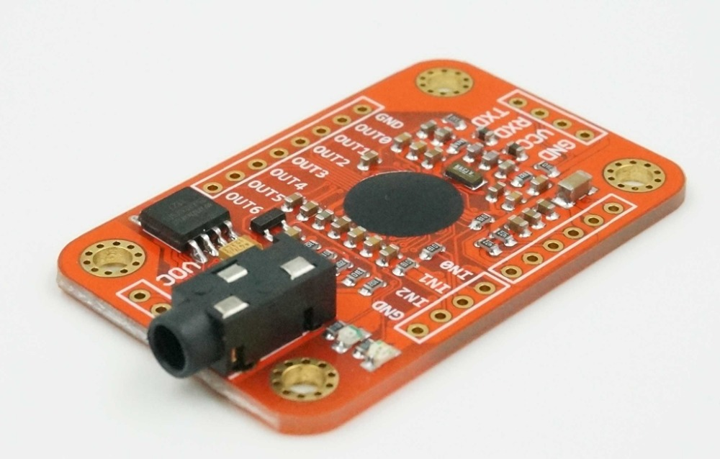
Figure 2.7 Voice Recognition module

Building the circuit

- Connect the vcc pin of VR module to +5V of Arduino
- Connect the GND pin of VR module to GND of Arduino
- Connect TX pin of VR module to pin 2 of Arduino
- Connect RX pin of VR module to pin 3 of Arduino
//voice recognition module and //srs main page.

Chapter 3

SOFTWARE REQUIREMENT SPECIFICATIONS

3.1 Software Requirements and Specification

The goal of software requirement and specification is to describe what the proposed should do. It is the medium through which the user needs are accurately specified. It provides reference for the validation of the final product.

3.1.1 Hardware Requirements

The hardware requirements for this project are

- Arduino Uno Board
- Light Sensing module
- Laser diodes
- Temperature sensor
- Real time clock
- Voice recognition module

3.1.2 Software Requirements

The Software requirements for this project are

- Operating System : Windows XP or higher, or Ubuntu or Mac
- Programming platform : Arduino IDE
- Programming Languages : C/C++

3.2 Arduino Uno

Figure 3.1: Arduino Uno

- Arduino/Genuino Uno is a microcontroller board based on the ATmega328P (datasheet).
- It has 14 digital input/output pins (of which 6 can be used as PWM outputs), 6 analog inputs, a 16 MHz quartz crystal, a USB connection, a power jack, an ICSP header and a reset button.
- It contains everything needed to support the microcontroller; simply connect it to a computer with a USB cable or power it with a AC-to-DC adapter or battery to get started.
- User can tinker with thier UNO without worrying too much about doing something wrong, worst case scenario you can replace the chip for a few rupees and start over again.
- "Uno" means one in Italian and was chosen to mark the release of Arduino Software (IDE) 1.0.
- The Uno board and version 1.0 of Arduino Software (IDE) were the reference versions of Arduino, now evolved to newer releases.
- The Uno board is the first in a series of USB Arduino boards, and the reference model for the Arduino platform; for an extensive list of current, past or outdated boards see the Arduino index of boards.

3.3 Light Sensing Module

Figure 3.2 : Light Sensing Module

- Detects if there is light or dark around, adjustable digital output trigger level, Analog+Digital output
- Photosensitive resistor module most sensitive to environmental light intensity is generally used to detect the ambient brightness and light intensity.
- Module light conditions or light intensity reach the set threshold, DO port output high, when the external ambient light intensity exceeds a set threshold, the module D0 output low;
- Digital output D0 directly connected to the MCU, and detect high or low TTL, thereby detecting ambient light intensity changes;
- Digital output module DO can directly drive the relay module, which can be composed of a photoelectric switch;
- Analog output module AO and AD modules can be connected through the AD converter, you can get a more accurate light intensity value.

3.4 Laser Diodes
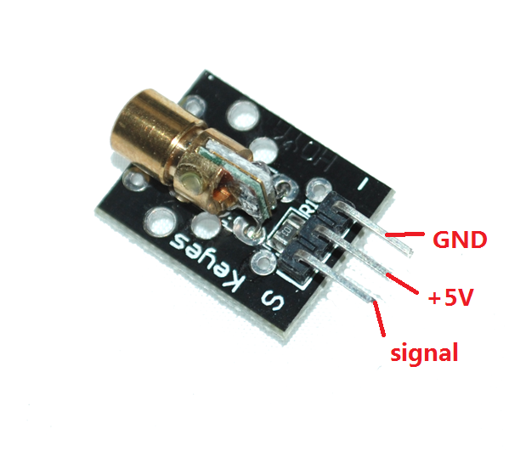
Figure 3.4: Laser Diode

. A laser diode, or LD also known as injection laser diode or ILD, is an electrically pumped semiconductor laser in which the active laser medium is formed by a p-n junction of a semiconductor diode similar to that found in a light-emitting diode.

. There are laser diode assemblies that have the automatic constant current driver built into the module thus such a module can be powered from a fixed constant voltage source.

3.5 Temperature Sensor
F
Figure 3.5:Temprature Sensor (KY-013)

- Temperature sensors are measurement devices that determine temperature by sensing a corresponding physical characteristic, such as electrical resistance, electromagnetic field (EMF) or thermal radiation
- The way a temperature sensor works depends upon the physical property that is measured.

- Specifications of temperature sensor are Temperature measurement, Accuracy, Stability, Probe type and Termination style.
- The temperature sensor is a NTC thermistor
- Multi-point temperature measurement Measures temperatures: -55°C / +125°C
- Accuracy: + / - 0.5°C
- The module is based on the thermistor (resistance increases with the ambient temperature changes) works, a sense of real-time To know the temperature of the surrounding environment changes,

- We send the data to the Arduino analog IO, then come down as long as we go through Jane Single programming will be able to convert the sensor output data Celsius temperature values and displayed, it is still easy to use, It effectively, thereby widely used in gardening, home alarm systems and other devices.

3.6 Real time clock module

- The DS3231 is a low-cost, extremely accurate I2C real-time clock (RTC) with an integrated temperaturecompensated crystal oscillator (TCXO) and crystal.
- The device incorporates a battery input, and maintains accurate timekeeping when main power to the device is interrupted.
- The integration of the crystal resonator enhances the long-term accuracy of the device as well as reduces the piece-part count in a manufacturing line.
- The DS3231 is available in commercial and industrial temperature ranges, and is offered in a 16-pin, 300-mil SO package.
- The RTC maintains seconds, minutes, hours, day, date, month, and year information. The date at the end of the month is automatically adjusted for months with fewer than 31 days, including corrections for leap year.
- The clock operates in either the 24-hour or 12-hour format with an AM/PM indicator.
- Two programmable time-of-day alarms and a programmable square-wave output are provided. Address and data are transferred serially through an I2C bidirectional bus.

Figure 3.6: RTC module

3.7 Voice Recognition Module

- ELECHOUSE Voice Recognition Module is a compact and easy-control speaking recognition board.
- This product is a speaker-dependent voice recognition module.
- It supports up to 80 voice commands in all.
- Max 7 voice commands could work at the same time. Any sound could be trained as command.
- Users need to train the module first before let it recognizing any voice command.
- This board has 2 controlling ways: Serial Port (full function), General Input Pins (part of function).
- General Output Pins on the board could generate several kinds of waves while corresponding voice command was recognized.
- On V3, voice commands are stored in one large group like a library.
- Any 7 voice commands in the library could be imported into recognizer.
- It means 7 commands are effective at the same time.

Figure 3.7 Voice Recognition module

3.7 Features of Arduino Uno

- Some of the key features of the Arduino Uno include:
- An open source design. The advantage of it being open source is that it has a large community of people using and troubleshooting it. This makes it easy to find some -one to help you debug your projects.
- An easy USB interface . The chip on the board plugs straight into your USB port and registers on your computer as a virtual serial port. This allows you to interface with it as through it were a serial device. The benefit of this setup is that serial communication is an extremely easy (and time-tested) protocol, and USB makes connecting it to modern computers and it is really really convenient.
- Very convenient power management and built-in voltage regulation. You can connect an external power source of up to 12v and it will regulate it to both 5v and 3.3v. It also can be powered directly off of a USB port without any external power.
- An easy-to-find, and dirt cheap, microcontroller "brain." The ATmega328 chip retails for about $2.88 on Digikey. It has countless number of nice hardware features like timers, PWM pins, external and internal interrupts, and multiple sleep modes.
- A 16mhz clock. This makes it not the speediest microcontroller around, but fast enough for most applications. 32 KB of flash memory is inbuilt in the Arduino
- 13 digital pins and 6 analog pins. These pins allow you to connect external hardware to your Arduino. These pins are key for extending the computing capability of the Arduino into the real world. Simply plug your devices and sensors into the sockets that correspond to each of these pins and you are good to go.
- An ICSP connector for bypassing the USB port and interfacing the Arduino directly as a serial device. This port is necessary to re-boot load your chip
- An on-board LED attached to digital pin 13 for fast an easy debugging of code.
- And last, but not least, a button to reset the program on the chip.

Hardware Specifications:
Microcontroller | ATmega328P
Operating Voltage | 5V
Input Voltage (recommended) | 7-12V
Input Voltage (limit) | 6-20V
Digital I/O Pins | 14 (of which 6 provide PWM output)
PWM Digital I/O Pins | 6
Analog Input Pins | 6
DC Current per I/O Pin | 20 mA
DC Current for 3.3V Pin | 50 mA
Flash Memory | 32 KB (ATmega328P)  of which 0.5 KB used by bootloader
SRAM | 2 KB (ATmega328P)
EEPROM | 1 KB (ATmega328P)
Clock Speed | 16 MHz
LED_BUILTIN | 13
Length | 68.6 mm
Width | 53.4 mm
Weight | 25 g
Table 3.1

3.8 Features of VR module
- Support maximum 80 voice commands, with each voice 1500ms (one or two words speaking)
- Maximum 7 voice commands effective at same time
- Arduino library is supplied readily along with the example programs.
- Easy Control: UART/GPIO , few commands to record , train and load.
- User-control General Pin Output
- Easily programmable.

Hardware Specifications
Table 3.2
Voltage | 4.5-5.5v
Current | <40mA
Digital interface | 5V TTL level for UART interface and GPIO
Analog Interface | 3.5mm mono-channel microphone connector + microphone pin interface
Size | 31mm x 50mm
Recognition accuracy | 99% (under ideal environment)

//design

Chapter 4

DESIGN

In this chapter, the architectural design is presented first and then the functional architecture overview, followed by a detailed description of module diagrams, sequence diagrams and use case diagrams.

- NOTE : EVERY DIAGRAMS MUST BE CHANGED ACCORDING TO OUR SPECIFICATION> LASER HAAKBEKU ELLAVDRALLU.

Chapter 5

Implementation

This chapter gives the implementation details of different sensors.

Detects if there is light or dark around, adjustable digital output trigger level, Analog and Digital output . Photosensitive resistor module most sensitive to environmental light intensity is generally used to detect the ambient brightness and light intensity.

Device Name | Light Sensing Module
Function | Sensing the light and giving the value accordingly
void setup()
{
Serial.begin(9600);
Serial.print("Visitor Counter");
delay(2000);
pinMode(in, INPUT);
pinMode(out, INPUT);
}

Device Name | Light Sensing Module
Function | OUT()  To decrement the value of visitor in a room.
void OUT()
{
if(count>0)
count--;
Serial.print("Person In Room:");
Serial.print(count);
delay(1000);
}

Device Name | Light Sensing Module
Function | IN()  To increment the value of visitor in a room.
void IN()
{
count++;
Serial.print("Person in room" );
Serial.print(count);
delay(1000);
}

Device Name | Temperature Sensor
Function | Sensing temperature at regular intervals

double Thermistor(int RawADC) {
double Temp;
Temp = log(10000.0*((1024.0/RawADC-1)));
Temp = 1 / (0.001129148 + (0.000234125 + (0.0000000876741 * Temp * Temp ))* Temp );
Temp = Temp - 273.15;
return Temp;
}

Device Name |  | Temperature Sensor
Function |  | analogRead()
int readVal=analogRead(sensorPin);
double temp = Thermistor(readVal);

Serial.println(temp); // display tempature

Device Name | RTC module
Function | Setting date and time

rtc.begin();
rtc.setDOW(WEDNESDAY);
rtc.setTime(12, 0, 0);
rtc.setDate(1, 1, 2014);

Device Name | RTC module
Function | To print current date and time
DateTime now = rtc.now();
Serial.print(now.year(), DEC);
Serial.print('/');
Serial.print(now.month(), DEC);
Serial.print('/');
Serial.print(now.day(), DEC);
Serial.print(daysOfTheWeek[now.dayOfTheWeek()]);
Serial.print(now.hour(), DEC);
Serial.print(':');
Serial.print(now.minute(), DEC);
Serial.print(':');
Serial.print(now.second(), DEC);

Device Name | LDR
Function | To get the values
int sensor_value = analogRead(A1);
Serial.println(sensor_value);
Device Name | LDR
Function | To Switch the led on and off
if (sensor_value > 150)// the point at which the state of LEDs change
{
digitalWrite(led, LOW); //sets LEDs ON
}
else
{
digitalWrite(led,HIGH); //Sets LEDs OFF
}

Device Name | Voice recognition module
Function | To train the module
void setup(void)
{
myVR.begin(9600);

/** initialize */
Serial.begin(115200);
Serial.println(F("Elechouse Voice Recognition V3 Module \"train\" sample."));

printSeperator();
Serial.println(F("Usage:"));
printSeperator();
printHelp();
printSeperator();
cmd_cnt = 0;
}

Device Name | Voice recognition module
Function | To switch on led using VR
void loop()
{
int ret;
ret = myVR.recognize(buf, 50);
if(ret>0){
switch(buf[1]){
case onlight:
/** turn on LED */
digitalWrite(led, HIGH);
digitalWrite(relay1,LOW);
break;
case offlight:
/** turn off LED*/
digitalWrite(led, LOW);
digitalWrite(relay1,HIGH);
break;
case fanon:
digitalWrite(relay2,LOW);
break;
case fanoff:
digitalWrite(relay2,HIGH);
default:
Serial.println("Record function undefined");
break;
}
printVR(buf);
}
}

//Software testing

Chapter 6

SOFTWARE TESTING

Software Testing is a process of investigation conducted for the purpose to provide stakeholders with information about quality of the software or hardware product and even service under test. Even testing can provide an independent, objective view of the product to allow the business to understand and risk involved in the implementation of software development. There is no limit for the process of executing a program or application from the intent of finding defects in the software or hardware product.

Another definition can be given as, it is the process of validating and verifying product has met necessary criteria.

- To check requirements are meet that guided its development and design.

- To check whether work is according to expectation.

- To check whether it has implemented with a unique characteristics.

- To check whether it has satisfied stakeholders need.

Testing mainly dependent on the methodology is adopted, and which can be implemented at any given time through the process of development. In certain cases, effort of testing occurs normally after when requirements are defined and development process has been finished. Agile process is adopted to test the product, to know effort simultaneously.

6.1 Testing Environment

There are number of software development models, which will focus differently on test from the point in process of development. Agile model will belongs to such new model, which implements a test driven from the perspective of development and place a rapid increase portion from the testing point of view before it moves to a formal team for testing.

The traditional model in testing occurs, after the necessary requirement has been defined and development process has been finished. The main goal of any testing process is to find errors/defects by adopting testing for individual program components. The components may be referred to as an object, module or function.

Verification: It is the process used to make sure that the product has satisfied the required conditions specified when the development phase started. In simple it can defined as, to make sure the system behavioral is same the way user expects.

Validation: It is the process used to make sure that the product has satisfied the required condition specified at the end of a development phase. In simple it can defined as, to make sure the software is built according to user requirement.

Error Detection: It is the process that every testing process should attempt to make thing go wrong, to determine if something occurs when it is required and something occurs when it is not required.

Testing goals are as follows:

- To know clear difference among defect testing and validation tests.

- To know objective of component testing and system tests.

- To know statistics for generating test cases.

- To know the unique characteristics of tools used for automation.

The process of testing can be grouped from the perspective they are added in the development of software product, or by indicating the level of testing. The important level during any process of development is as: system testing, unit testing, and integration testing.

- Unit Testing

- Integration Testing and

- System testing.

Unit Testing

- There exist a number of components in every sub-system. Every component is tested using respective test procedures. Each component is tested individually or with other components based on their needs.

- Unit test focuses verification effort on the smallest unit of software design component or module.

Integration Testing

- Integration tests are designed to test integrated software components to determine if they actually run as one program.

System Testing

- Testing performs a very critical role for quality assurance and for ensuring reliability of the software. During testing, the program should be tested with a set of test cases and the output of the program for the test cases is evaluated to determine if the program is performing as expected. Testing forms the first step in determining the errors in a program. The success of testing in revealing errors in program depends critically on the test cases.

- Testing a large system is a complex activity and hence it has to be broken into smaller activities, due to this incremental testing is generally performed for project in which components and sub-systems of a system are tested separately before integrating them to form the system for system testing. Integration of various components of the system is an important issue that the testing phase has to deal with.

Test data are inputs which have been devised to test the system whereas test cases are inputs to test the system and the outputs are predicted from these inputs if the system operates according to its specification. This is to examine the behavior in a cohesive system. The test cases are selected to ensure that the system behavior can be examined in all possible combinations of conditions.
Accordingly, expected behavior of the system under different combinations is given. Therefore test cases are selected which have inputs and the outputs are on expected lines, inputs that are not valid and for which suitable messages must be given and inputs that do not occur very frequently which can be regarded as special cases. In this chapter, several test cases have been explained.

//Don’t know the test case, will put this after discussion with whole team.

Till now 40 pages have been covered , another 5 pages would be Design another 3 pages would be (first pages) abstract,certificate,etc another 8 pages for result and snapsots and another 2 pages for test cases another page for future work and conclusion another page would be for references.
Totally it would come near 65 pages. We can extend that to 70 by putting the versions of Arduino. And not more than that.

